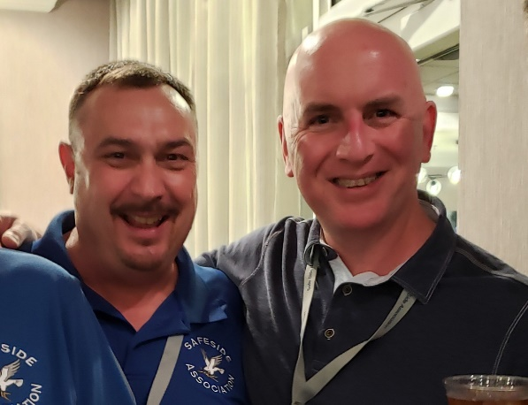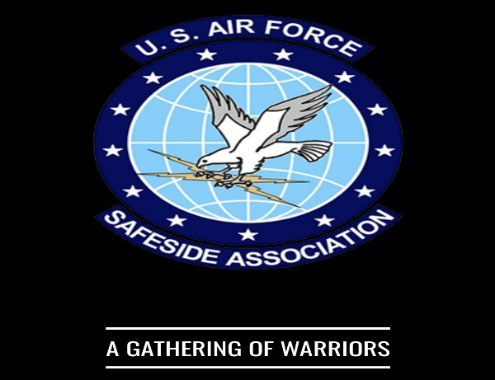

My SAFESIDE Brothers and Sisters!

REUNION POSTPONED: At our monthly virtual SAFESIDE Board of Directors (BOD) meeting it was decided to postpone the April 2022 SAFESIDE Reunion until later this year. The Moody AFB area is still experiencing high COVID virus infection rates and the base is still in Health Protection Condition “CHARLIE” which severely restricts large gatherings of personnel on base. Additionally, we do not want to put our members, or members of the Moody AFB community, at increased risk of exposure to the virus. We are disappointed with the delay but looking forward to a healthy and happy reunion later in 2022. We are planning a new date now and will communicate that date as soon as it’s set.

With regards to the Memorial Bench dedication, it was decided since our Memorial Bench project was so far along it was best to go ahead with installation and have the formal dedication at our next reunion, whatever that date might be. The bench will represent all units associated with SAFESIDE. It will be built on the grounds of the current 820 BDG Memorial. It is important that we have as many SAFESIDERS present for this dedication ceremony as possible.
The bench will be identical to the SAFESIDE Memorial Bench, at The Museum of the United States Air Force, Wright-Patterson AFB, Ohio. This endeavor will cost the Association approximately $5,000. We solicit your help to build this lasting monument to all our service in the defense of our country. Donations are still needed and much appreciated! You may donate by going to our SAFESIDE Website at https://www.SAFESIDEassociation.org. You may also donate by check. Send checks to our Treasurer, Ray Silhavy, 2834 Red Maple Drive, Katy, TX 77494. Make your check payable to Operation SAFESIDE, Inc. Annotate the memo section with "SAFESIDE Bench Donation”.

There will be a “Google Meet” SAFESIDE Association Membership Virtual Meeting on Wednesday, 23 Mar 22 at 2000 hrs Eastern Standard Time. This meeting is intended to be a “State of the Association Address” for all SAFESIDE Association Members. The goal of this meeting is to discuss the status of our Association, discuss reunion plans, and most importantly to answer any questions you may have. More detailed information of our virtual meeting will follow.

Hamish and I encourage each of you to contact us if we can be of assistance to any of you. We truly hold these positions to be of service to you and to ensure that the Association is continuing to maintain our legacy and traditions.

Feel free to contact me or Hamish at:
dtrderry@gmail.com (813) 777-3367 or Hamish at: Hamish.stewartsmith@gmail.com (610) 246-7778

Very Respectfully,
Don “The Ranger” Derry, President & Hamish Stewart-Smith, Vice President

“JOINED TO FIGHT”

